Project Structure

|  |  |
| --- | --- |
| DATE | 21 October 2022 |
| TEAM ID | PNT2022TMID30482 |
| PROJECT NAME | AI-powered Nutrition Analyzer for Fitness Enthusiasts |

Create a Project folder that contains files as shown below

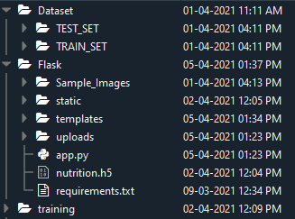

* Dataset folder contains the training and testing images for training our model.
* We are building a Flask Application that needs HTML pages stored in the templates folder and a python script app.py for serverside scripting
* we need the model which is saved and the saved model in this content is a nutrition.h5
* templates folder contains home.html, image.html, imageprediction.html pages.
* Statis folder had the css and js files which are necessary for styling the html page and for executing the actions.
* Uploads folder will have the uploaded images(which are already tested).
* Sample_images will have the images which are used to test or upload.
* Training folder contains the trained model file.